Lesson 9 Report
Vulnerable Dependencies

Abdulaziz Alwarthan
Student ID: 202160310

1. Vulnerability Summary
The vulnerability is unsafe deserialization caused by the vulnerable dependency node-serialize. The affected component is the order manager Lambda function, which handles requests sent to the /order API endpoint.
The security impact is Remote Code Execution. An attacker can send a specially crafted payload that is executed by the Lambda function before the normal application logic finishes.

2. Why It Happens / Root Cause
The root cause is that the backend used serialize.unserialize() on data controlled by the user. The old code parsed both event.body and event.headers using node-serialize.
const serialize = require('node-serialize');
var req = serialize.unserialize(event.body);
var headers = serialize.unserialize(event.headers);
This is dangerous because node-serialize can deserialize special function payloads such as _$$ND_FUNC$$_function(){...}(). When the function marker is processed by unserialize(), the code inside the payload can run in the Lambda environment.

3. Exploit and Evidence
Screenshot 1: Vulnerable order-manager.js code before fixing
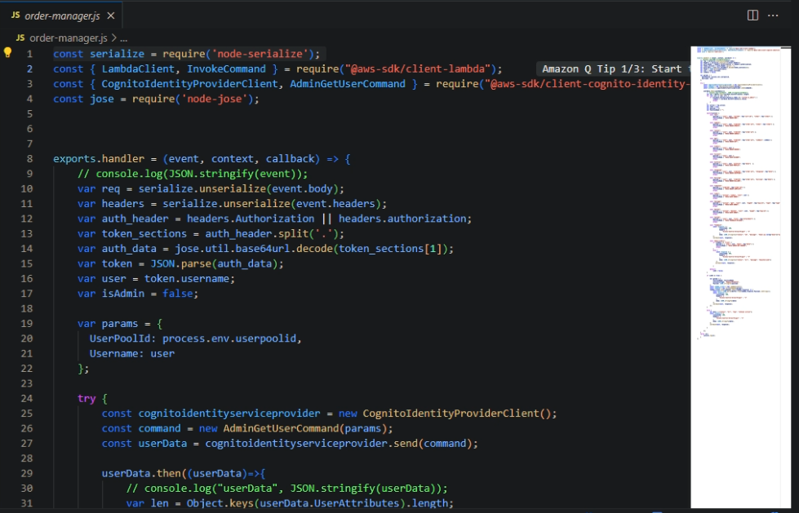
This screenshot shows the vulnerable code before fixing. The file imports node-serialize and uses serialize.unserialize() on the HTTP request body and headers. Since the request body comes from the user, an attacker can control what gets deserialized.
Screenshot 2: Exploit command sent to the /order API
The exploit was sent using curl to the /order API endpoint. The payload used the node-serialize function marker to execute JavaScript. The command returned an internal server error, but this does not mean the exploit failed. In this lesson, the important proof is the backend CloudWatch log.
curl -X POST "https://3f8ck6szn6.execute-api.us-east-1.amazonaws.com/Stage/order" -H "Content-Type: application/json" -d "{...node-serialize payload...}"
Screenshot 3: CloudWatch proof that the malicious payload executed
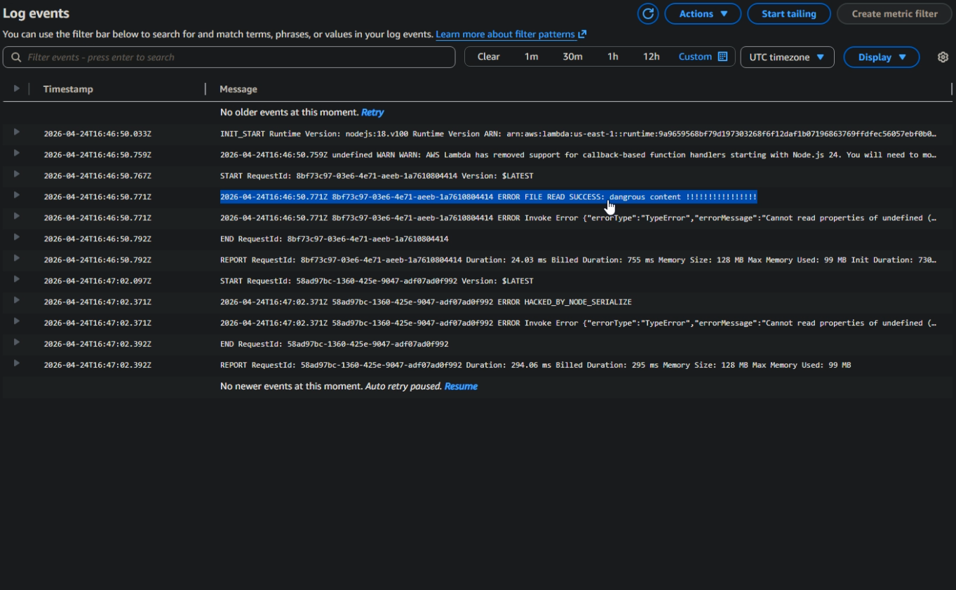
CloudWatch shows FILE READ SUCCESS and HACKED_BY_NODE_SERIALIZE. This proves that the malicious payload executed inside the Lambda function. The payload wrote data into /tmp, read it back, and printed the result to the logs.

4. Impact
The impact is serious because the attacker-controlled payload runs inside the Lambda execution environment. This may allow writing files to /tmp, reading temporary files, printing sensitive runtime data, or abusing the permissions assigned to the Lambda role. Even when the API response shows an error, the malicious code may already have executed.

5. Fix Applied
The fix was to remove node-serialize from the request parsing path and replace unsafe deserialization with JSON.parse. API Gateway already provides headers as an object, so headers do not need to be deserialized.
var req = JSON.parse(event.body);
var headers = event.headers || {};
var auth_header = headers.Authorization || headers.authorization;
JSON.parse only parses JSON data. It does not execute JavaScript functions. Therefore, the malicious _$$ND_FUNC$$_function(){...}() payload becomes normal text instead of executable code.
Screenshot 4: Code after replacing unsafe deserialization with JSON.parse
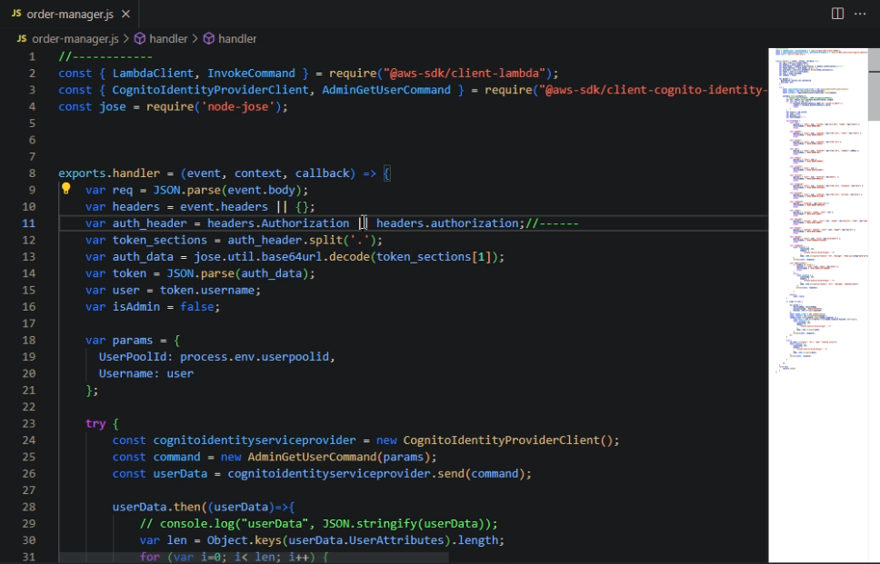
This screenshot shows the fixed code. The vulnerable node-serialize import was removed, and the request body is now parsed using JSON.parse. The headers are read directly from event.headers.

6. Verification After Fix
Screenshot 5: CloudWatch logs after the fix
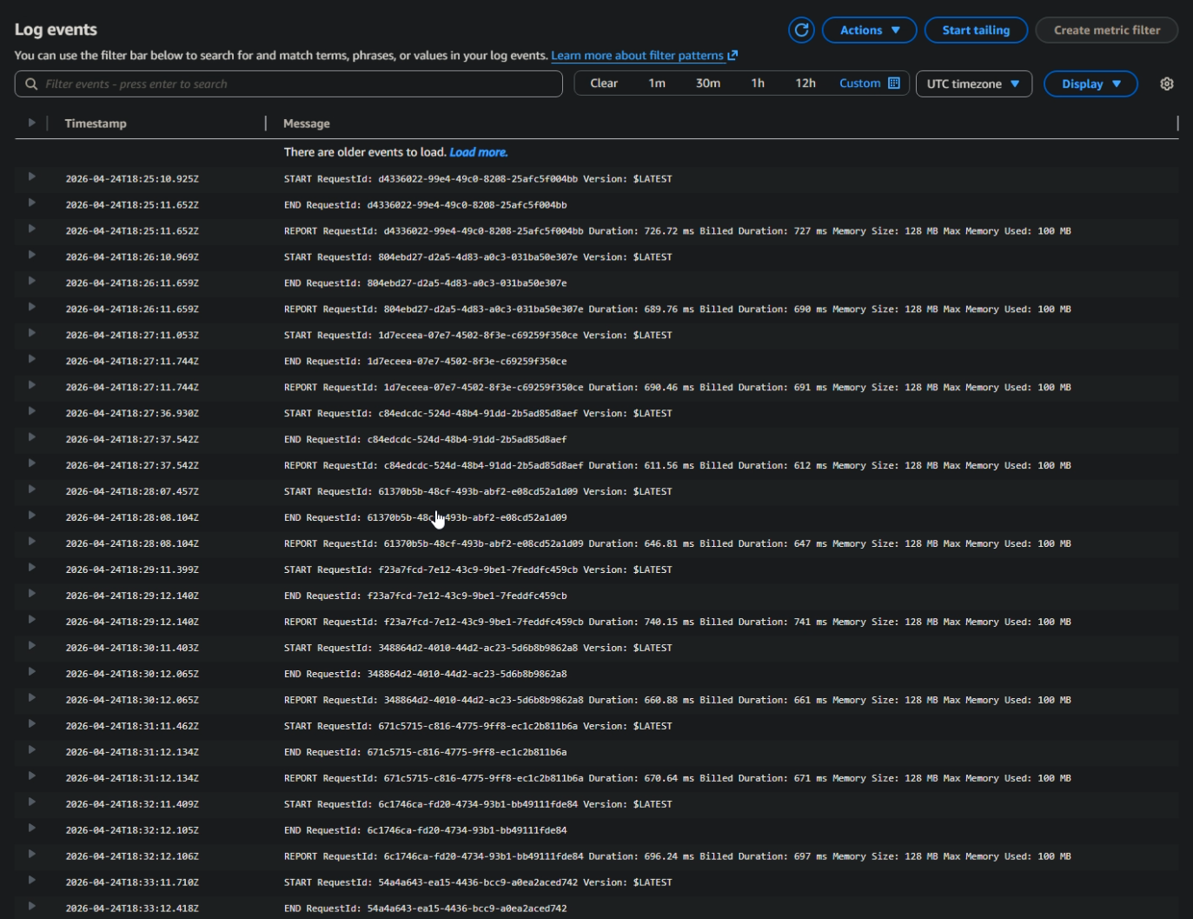
After deploying the fix, the same exploit test was repeated. The CloudWatch log no longer shows FILE READ SUCCESS or HACKED_BY_NODE_SERIALIZE. This proves that the malicious payload no longer executed after replacing unsafe deserialization with JSON.parse.

7. Before and After Summary
Stage | Behavior | Result
Before Fix | node-serialize.unserialize() processed user-controlled input | Payload executed and appeared in CloudWatch
Fix | Removed node-serialize and used JSON.parse(event.body) | Input treated as data instead of executable code
After Fix | Same exploit was tested again | No malicious execution appeared in CloudWatch

8. Conclusion
Lesson 9 demonstrated a vulnerable dependency issue in the DVSA order manager Lambda function. The function used node-serialize to unserialize attacker-controlled request data, which allowed JavaScript code execution. The exploit was proven through CloudWatch logs showing FILE READ SUCCESS and HACKED_BY_NODE_SERIALIZE. The fix replaced unsafe deserialization with JSON.parse and used event.headers directly. After redeployment, the same malicious payload no longer executed, confirming that the vulnerability was remediated.

